**SETTING UP APPLICATION ENVIRONMENT**

**CREATE A FLASK PROJECT**

Flask is a micro web framework written in Python. It is classified as a microframework because it does not require particular tools or libraries. It has no database abstraction layer, form validation, or any other components where pre-existing third-party libraries provide common functions.

The steps to create and execute a flask program is mentioned below.

**STEPS TO CREATE A FLASK PROJECT**

The following steps are followed to create the flask project.

**STEP 1: PYTHON INSTALLATION**

* The latest version of python is downloaded from **PYTHON.ORG.**
* Install python by running the setup file.

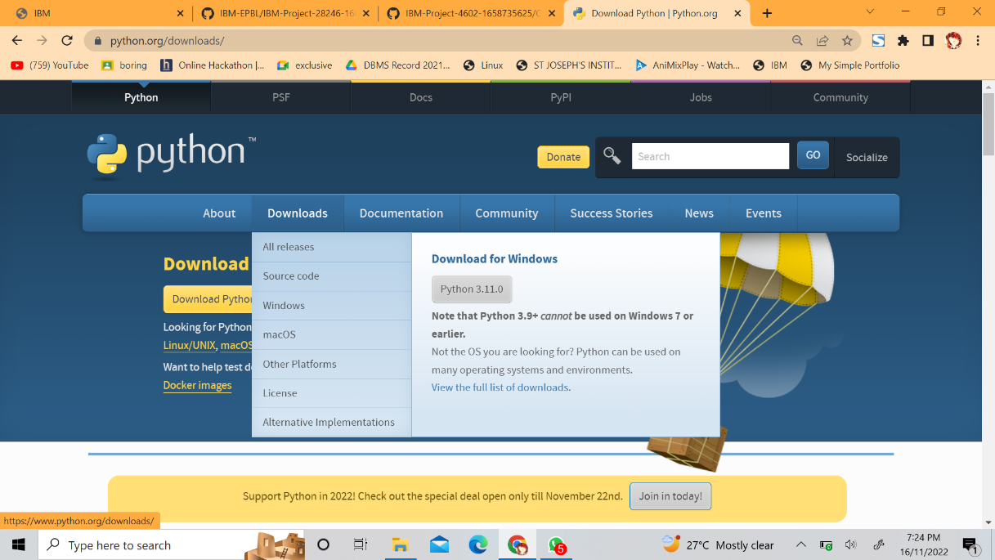

**STEP 2 : ANACONDA INSTALLATION**

* The latest version of Anaconda is downloaded from their official site.

[**https://www.anaconda.com/**](https://www.anaconda.com/)

* Its then installed by running the setup file.



**STEP 3 : INSTALL FLASK**

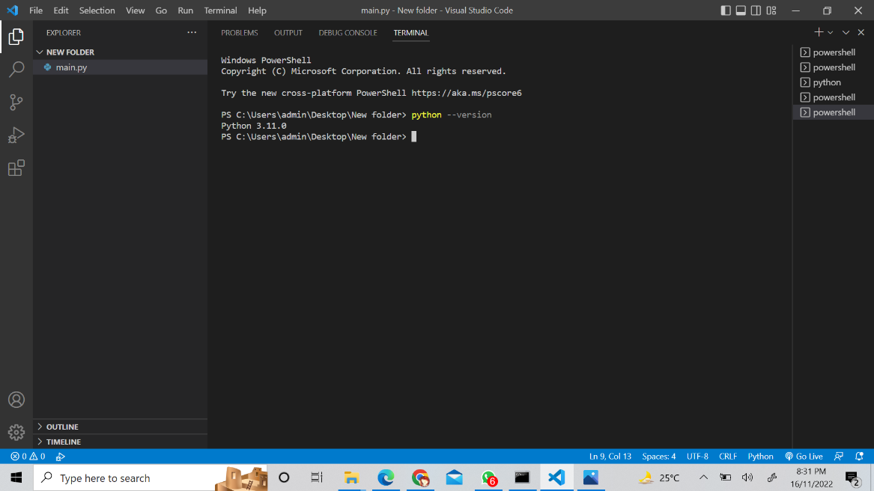 Flask is installed using the command **pip install flask .**

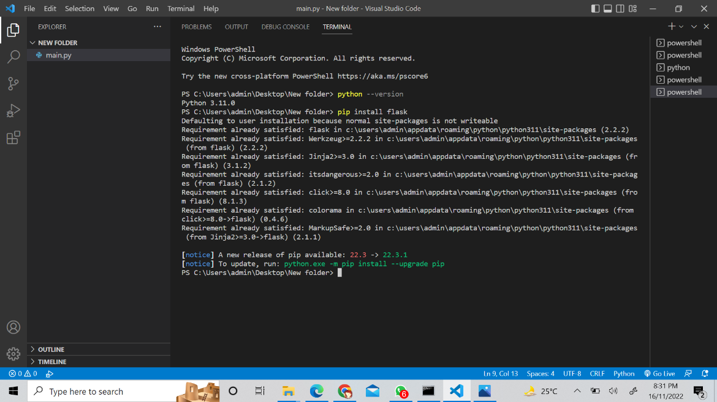

**STEP 4 : CREATE THE PROGRAM**

* A new python file is created .
* The program is coded and executed.

**PROGRAM**

from flask import Flask

app = Flask(__name__)

@app.route('/')

def hello_world():

return "HELLO WORLD !!!"

if __name__ == "__main__":

app.run()

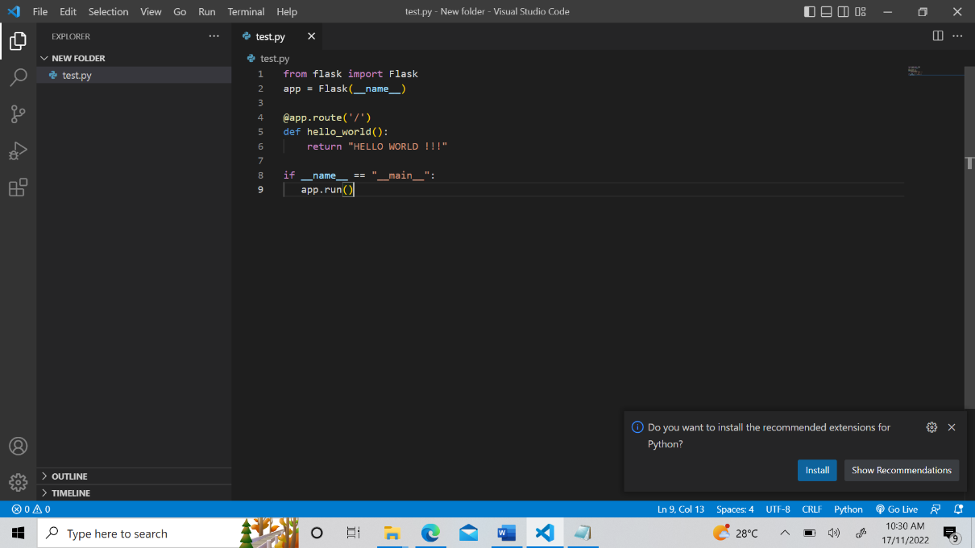

**STEP 5 : EXECUTION**

* The program is executed using the command **python filename.py**
* An ip address is generated.

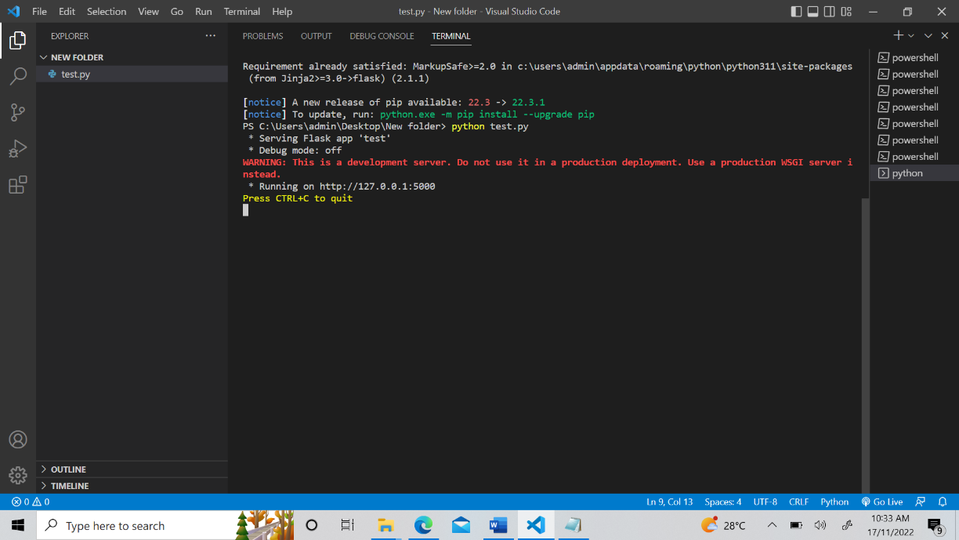

**STEP 6 : OUTPUT**

* 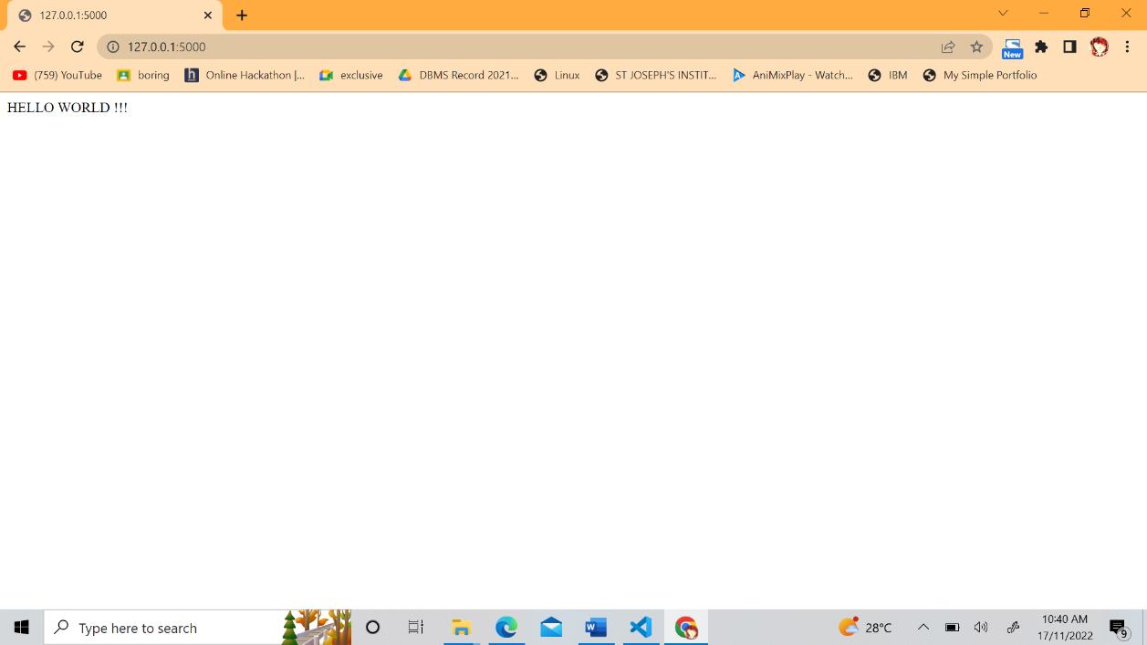The ip address is opened in a web browser.